C4-S2 LEARNING
CSS FLEXBOX
 Are you lost?
- You can check the following resources: Guide to Flexbox properties

Activity 1 (single line)
Look at the following start HTML and CSS code…

HTML | CSS (INITIAL RULES)
<body>  <div class="container">  <div class="item" id="i1">1</div>  <div class="item" id="i2">2</div>  <div class="item" id="i3">3</div>  </div>  </body> | .container {  display: flex;  height: 200px;  font-size: 3em;  text-align: center;  }  .item {  width: 200px;  height: 100px;  }

We want you to understand the following properties and their possible values:

PROPERTIES | POSSIBLE VALUES
flex-direction | row, column, row-reverse, column-reverse
justify-content | flex-start, flex-end, center, space-between, space-around
align-items | flex-start, flex-end, center, baseline
align-self | flex-start, flex-end, center, baseline

TODO - Complete the missing part on the below 10 rows (either write the CSS code or draw the HTML rendering)

CSS (ADDITIONAL RULES) | RENDERING
EXAMPLE 1
.container {  flex-direction: row;  justify-content: flex-end;  } | 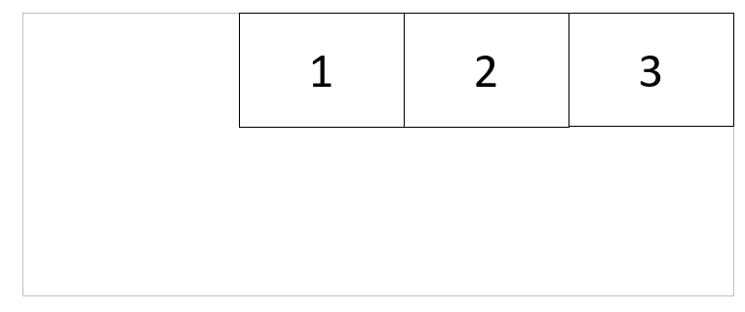
.container {  flex-direction: row-reverse;  justify-content: flex-start;  } |   3  2  1
.container {  flex-direction: row-reverse;  justify-content: flex-end;  } | 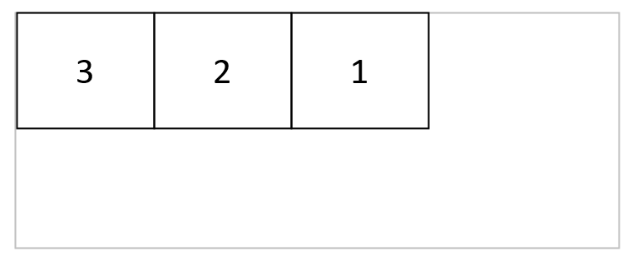
.container {  flex-direction: row;  justify-content: flex-end;  align-items: center;  } | 1  2  3
.container {  flex-direction: row;  justify-content: center;  align-items: center;  } | 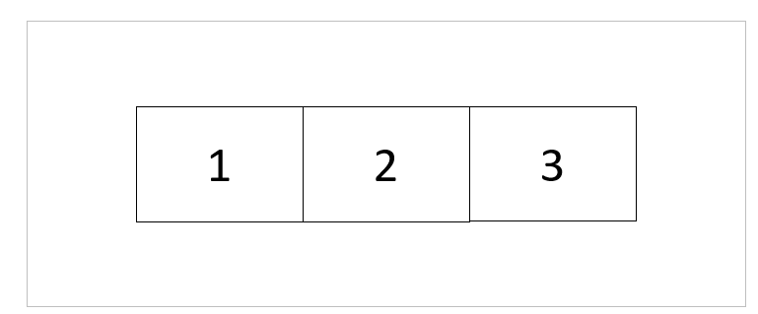
.container {  flex-direction: row;  justify-content: space-between;  align-items: center;  } | 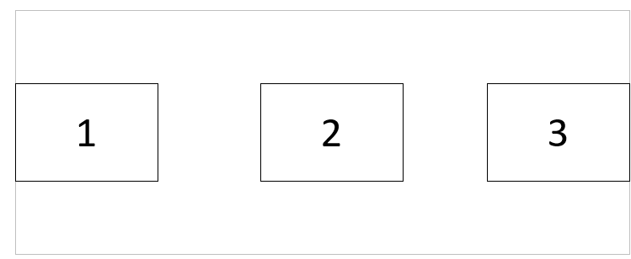
.container {  justify-content: space-between;  }  #i2 {  align-self: flex-end;  } | 1  2  3
.container {  justify-content: space-between;  }  #i1 {  align-self: flex-end;  }  #i3 {  align-self: flex-start;  } | 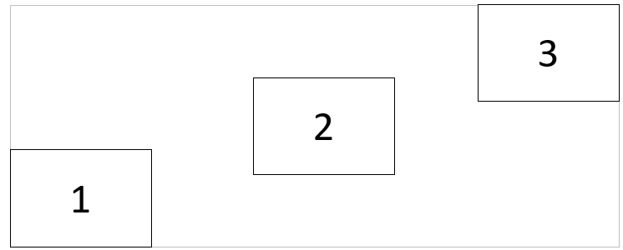
EXAMPLE 2
.container {  flex-direction: column;  }  #i3 {  align-self: flex-end;  } | 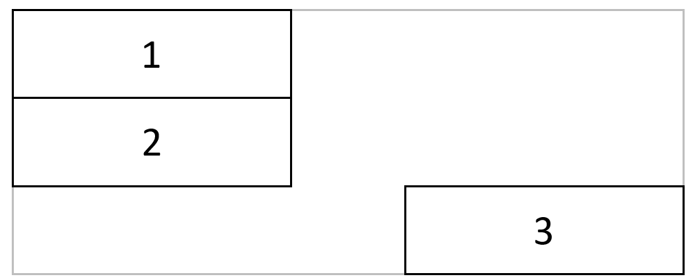
.container {  flex-direction: column;  align-items: flex-end;  } | 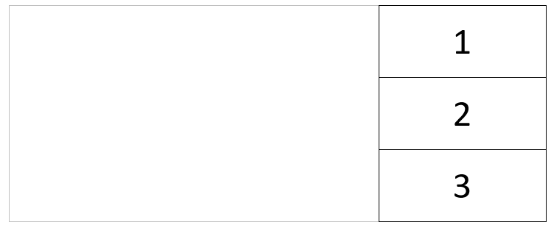
.container {  Justify-content: space-evenly;  align-items;: center;  } | 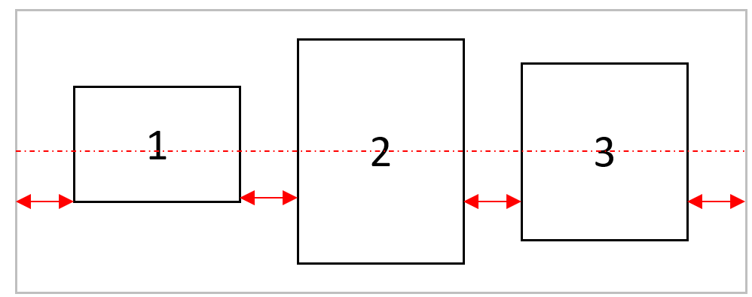
.container {  flex-direction: column-reverse;  align-items: center;  justify-content: center;  } | 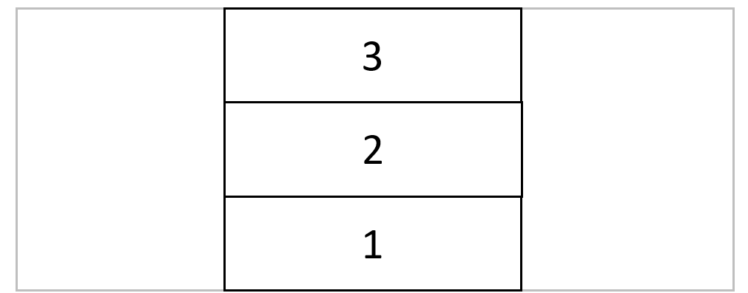

Activity 2 (wrap, grow, shrink)
Look at the following start HTML and CSS code…

HTML | CSS (INITIAL RULES)
<body>  <div class="items-container">  <div class="item">1</div>  <div class="item">2</div>  <div class="item">3</div>  <div class="item">4</div>  <div class="item">5</div>  <div class="item">6</div>  <div class="item">7</div>  <div class="item">8</div>  <div class="item">9</div>  </div>  </body> | .items-container {  display: flex;  gap: 1em;  }  .item {  width: 200px;  height: 200px;  }

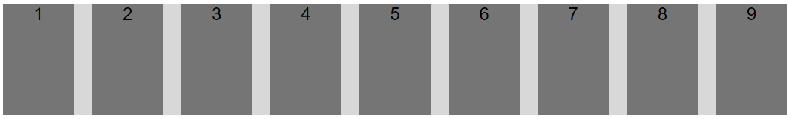
We want you to understand the following properties and their possible values:

PROPERTIES | POSSIBLE VALUES
flex-wrap | nowrap, wrap, wrap-reverse
flex-grow | An integer >= 0
flex-shrink | An integer >= 0
flex-order | An integer

TODO - Complete the missing part on the below 10 rows (either write the CSS code or draw the HTML rendering)

CSS (ADDITIONAL RULES) | RENDERING
.container {  flex-wrap: wrap;  } | 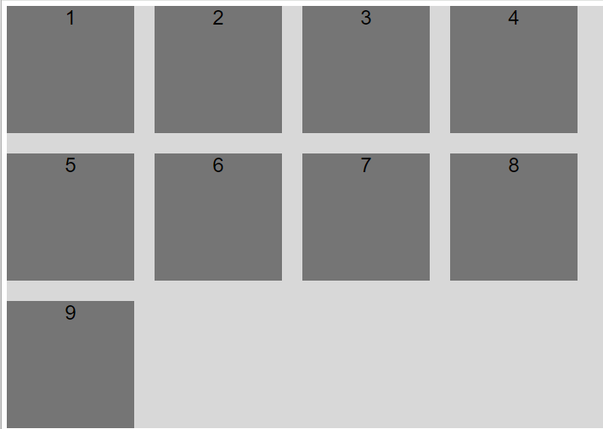
.container {  flex-wrap: wrap-reverse;  } | 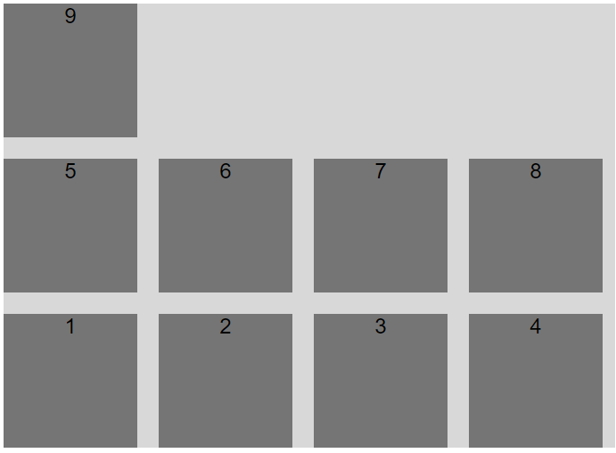

Activity 3 (grow, shrink and margin auto)
Look at the following start HTML and CSS code…

HTML | CSS (INITIAL RULES)
<div class="menu-container">  <div class="menu-item" id="home">Home</div>  <div class="menu-item" id="project">Project</div>  <div class="menu-item" id="help">Help</div>  </div> | .menu-container {  display: flex;  align-items: flex-start;  gap: 1em;  margin-bottom: 1em;  }  .menu-item {  width: 200px;  height: 50px;  }

- We want you to understand the usage to margins with flex items

- We want you to understand the following properties and their possible values:

PROPERTIES | POSSIBLE VALUES
flex-grow | An integer >= 0
flex-shrink | An integer >= 0
flex-order | An integer

TODO - Complete the missing part on the below 10 rows (either write the CSS code or draw the HTML rendering)

CSS (ADDITIONAL RULES) | RENDERING
#help {
margin-left: auto;
}

#project {
margin-left: auto;
}

#help {
flex:1
}
#home {
flex:1
}

#project {
flex:2
}

#help {
flex:3
}
#project {
flex-grow:1
}

